**Terraform Task-5**

1. **Watch the Terraform-05 video.**
2. **Execute the script shown in the video.**
3. **Create one EC2 instance with httpd installed using a Terraform script.**
4. **Set up S3 as backend for task 3.**
5. **Set up DynamoDB locking for task 3**

**-----------------------------------------------------------------------------------**

1. **Watch the Terraform-05 video.**

**Completed**

**2.Execute the script shown in the video.**

**Remote backends**

**State locking is used to lock the state file so that no two users can execute the state file at the same point of time.**

**Configure aws**

**resource "aws_s3_bucket" "s3_bucket" {**

**bucket = "s3backend"**

**acl = "private"**

**}**

**Terraform init**

**Terraform apply**

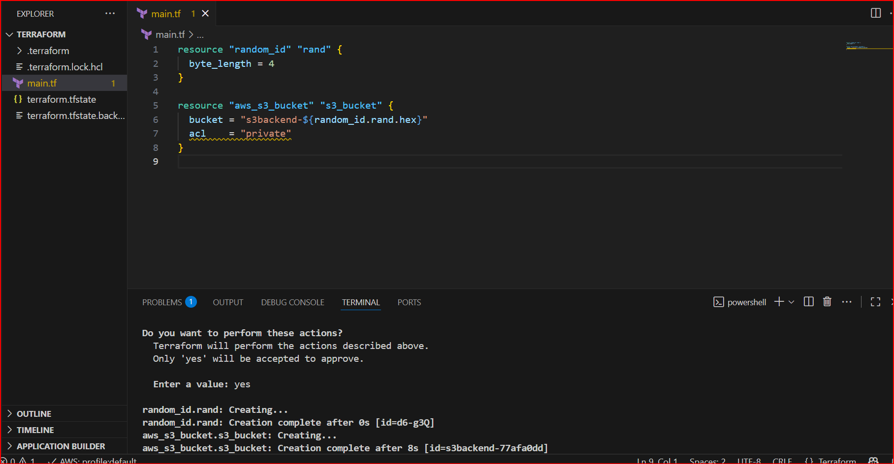

**This will create S3 bucket**

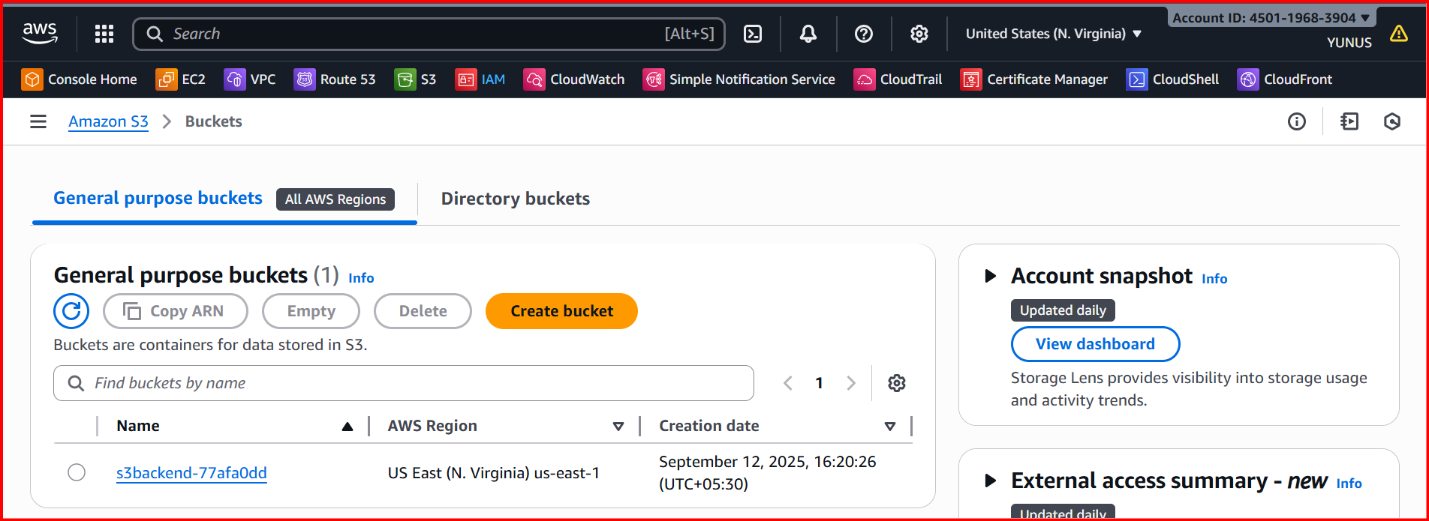

**resource "aws_dynamodb_table" "dynamodb-terraform-state-lock" {**

**name = "terraform-state-lock-dynamo"**

**hash_key = "LockID"**

**read_capacity = 20**

**write_capacity = 20**

**attribute {**

**name = "LockID"**

**type = "S"**

**}**

**}**

**Terraform init**

**Terraform apply**

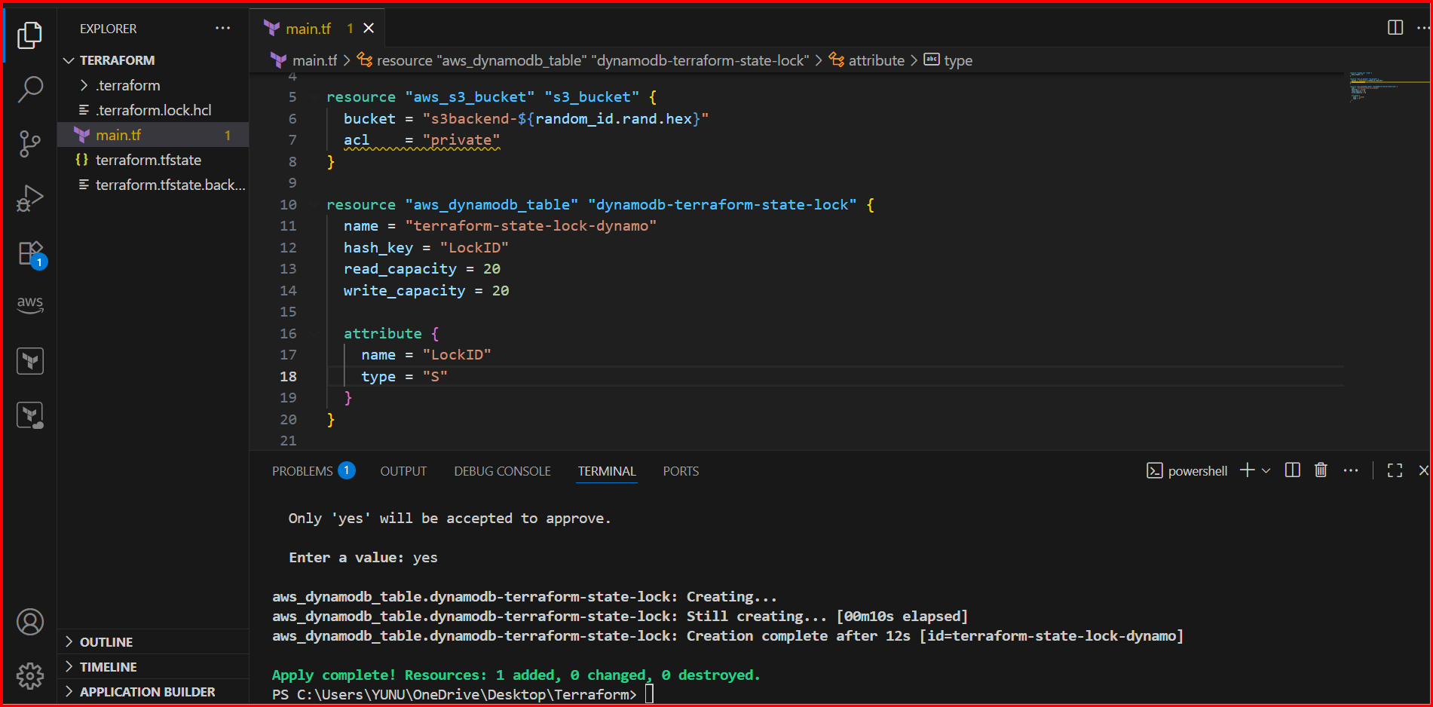

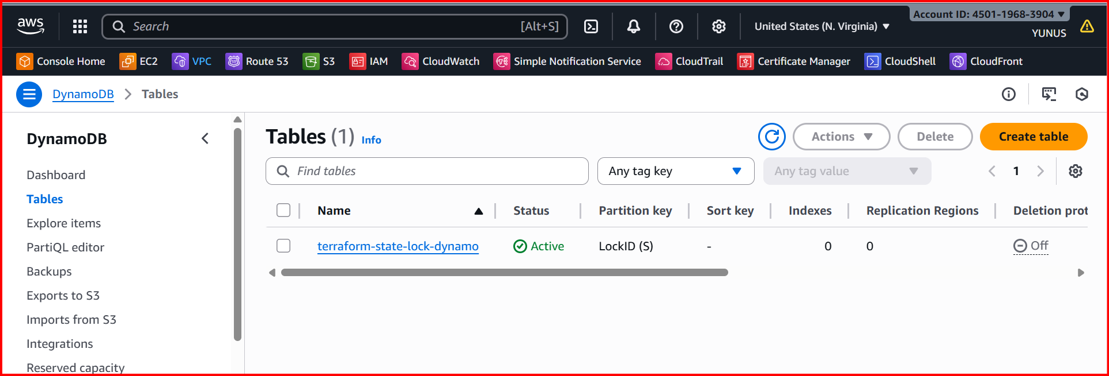

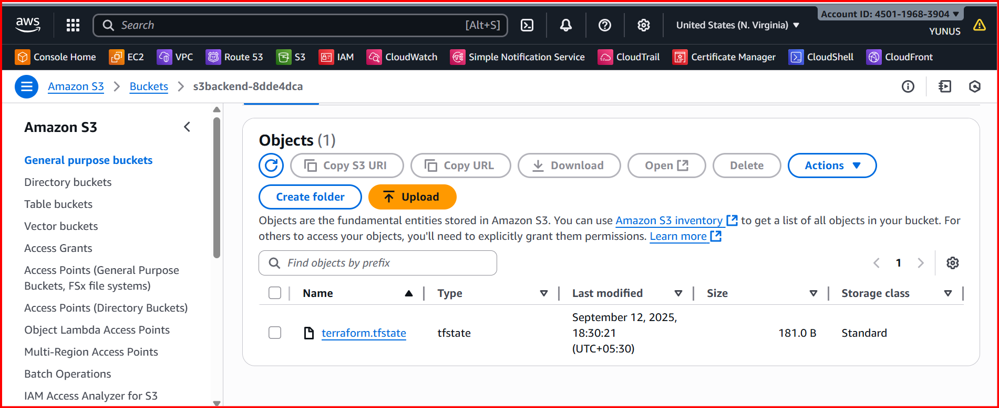

**3.** **Create one EC2 instance with httpd installed using a Terraform script**

**In terraform write the script**

**resource "aws_instance" "test-server" {**

**ami = "ami-0b09ffb6d8b58ca91"**

**instance_type = "t3.micro"**

**key_name = "jenkins"**

**tags = {**

**Name = "Test-server"**

**}**

**user_data = <<-EOF**

**#!/bin/bash**

**yum update -y**

**yum install -y httpd**

**systemctl enable httpd**

**systemctl start httpd**

**echo "<h1>Hello from Test-server</h1>" > /var/www/html/index.html**

**EOF**

**}**

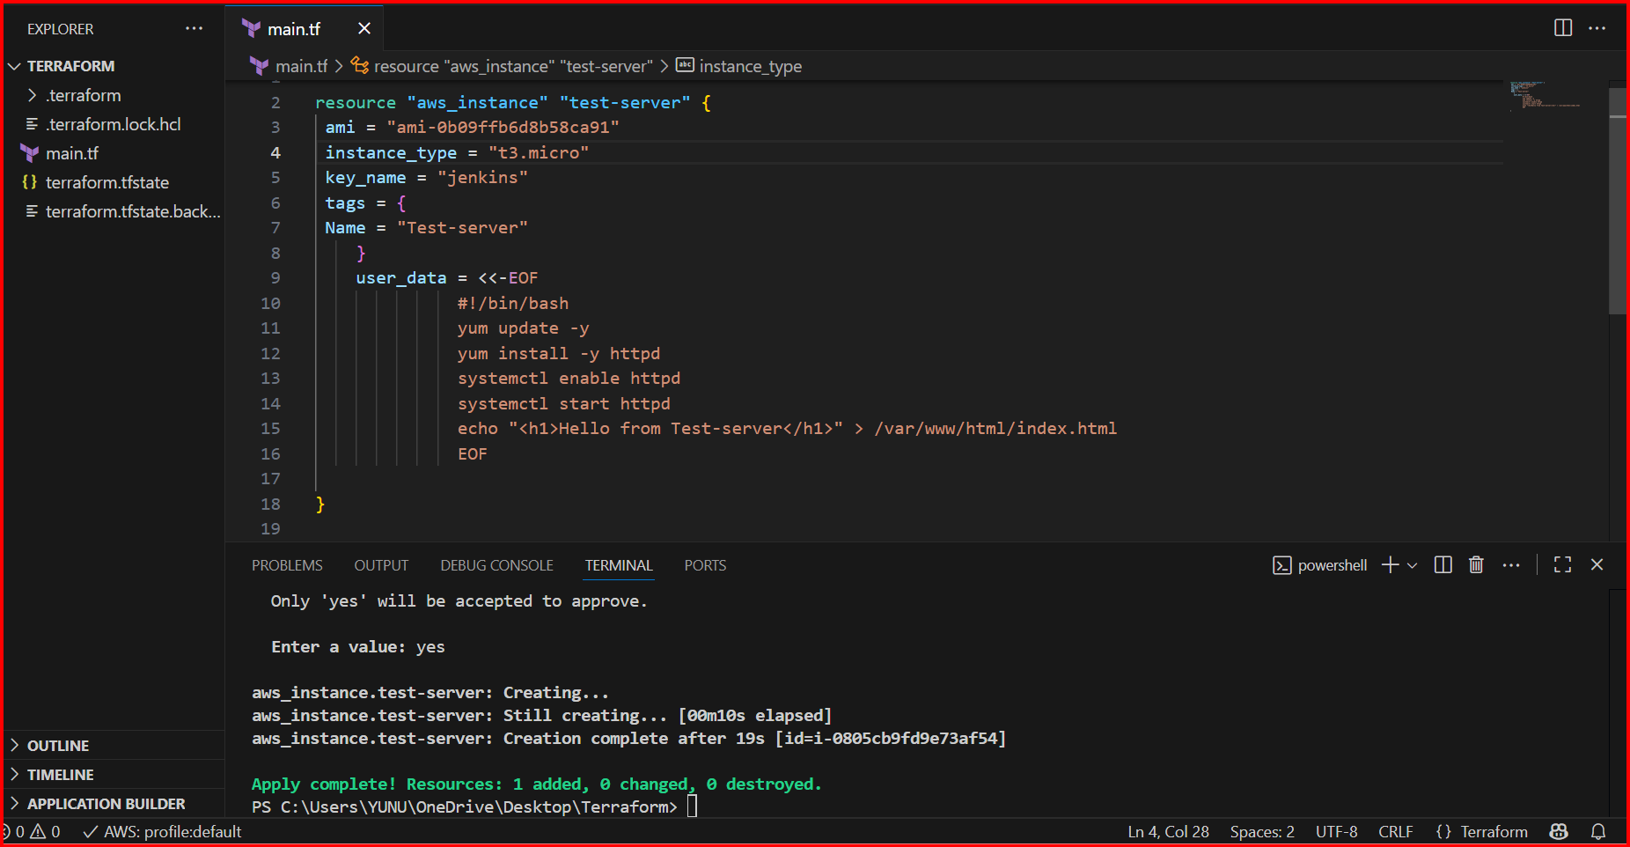

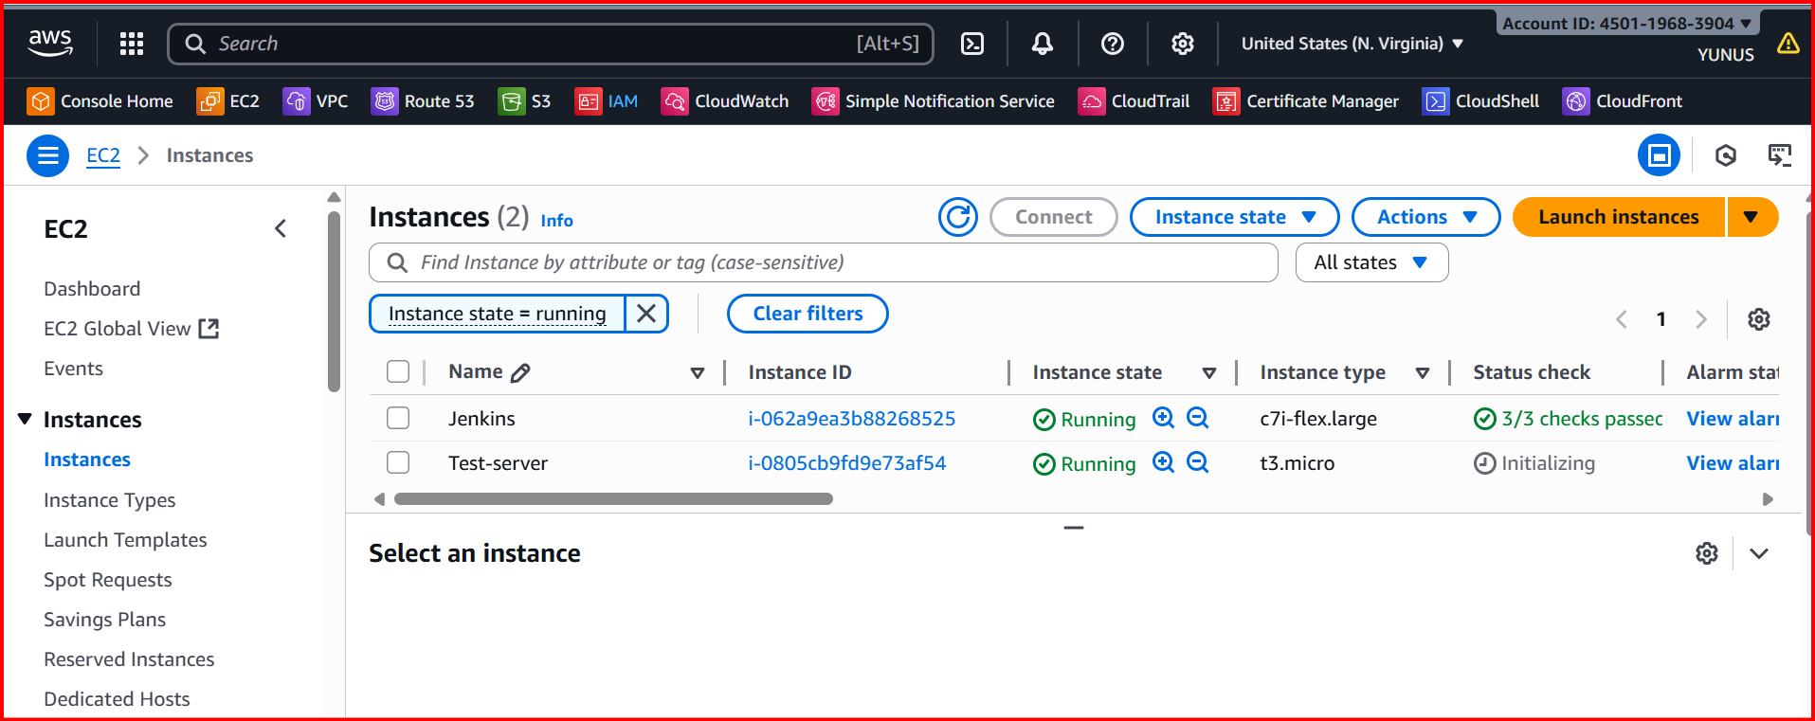

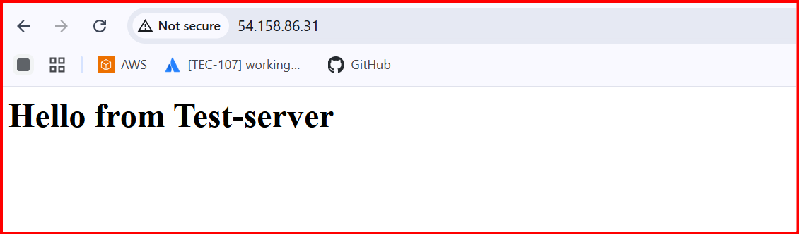

**4.Set up S3 as backend for task 3**

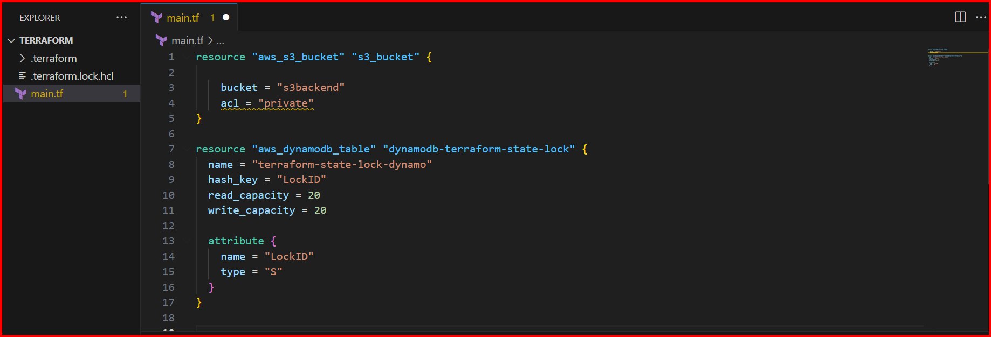

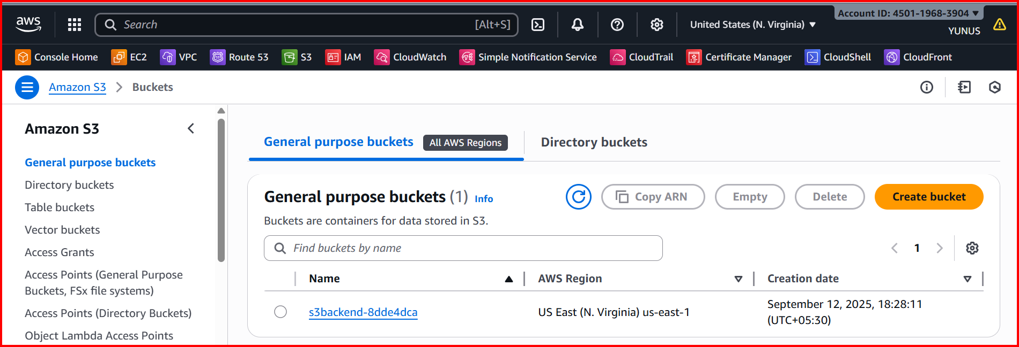

**5.Set up DynamoDB locking for task 3.**

